Lecture 1
The object of the “Technical Mechanics” course
Technical Mechanics may be defined as the science that describe the conditions of equilibrium or of the motion of the material bodies under the action of the forces. Technical Mechanics can be divided in three large parts: mechanics of the no deformable bodies (Theoretical Mechanics), mechanics of the deformable bodies (Strength of the Materials) and mechanics of solids (Theory of Mechanisms and Machines).
Theoretical Mechanics may be divided in other three parts: statics, kinematics and dynamics. Statics is that part of the theoretical mechanics which studies the transformation of the systems of forces in other simpler systems and the conditions of equilibrium of the bodies. Kinematics is the part of the theoretical mechanics that deals with the motions of the bodies without to consider their masses and the forces that acts about them, so kinematics studies the motion from geometrical point of view, namely the pure motion. Dynamics is the part of the theoretical mechanics which deals with the study of the motion of the bodies considering the masses of them and the forces that acts about them. Theoretical mechanics studies the simplest form of the motion of the material bodies, namely the mechanical motion. The mechanical motion is defined as that phenomenon in which a body or a part from a body modifies its position with respect to an other body considered as reference system.
In all these definitions the bodies are considered rigid bodies that are the no deformable bodies. It is known that the real bodies are deformable under the action of the forces. But these deformations are generally very small and they produce small effects about the conditions of equilibrium and of the motion.
Many consider Technical Mechanics as a science joined to the mathematics because it develops its theory based on mathematical proofs. At the other hands, Technical Mechanics is not an abstract science or a pure one, it is an applied science.

Fundamental notions in Theoretical Mechanics
Theoretical Mechanics or Newtonian mechanics uses three fundamental notions: space, time and mass. These three notions are considered independent one with respect to other two. They are named fundamental notions because they may be not expressed using other simpler notions and they will form the reference frame for to study the theoretical mechanics.
The notion space is associated with the notion of position. For example the position of a point P may be defined with three lengths measured on three given directions, with respect to a reference point. These three lengths are known under the name of the coordinates of the point P. The space in theoretical mechanics is considered with the next proprieties: infinity large, three dimensional, continuous, homogeneous and isotropic. The space defined in this way is the Euclidian space.
Mechanical phenomena have durations and they are produced in any succession. Theoretical Mechanics considers as fundamental notion the time having the following proprieties: infinity large, one-dimensional, continuous, homogeneous and irreversible. The time between two events is named interval of time.
The notion of mass is used for to characterize and compare the bodies in the time of the mechanical events. The mass in Theoretical Mechanics is the measure of the inertia of bodies in translation motion and will represent the quantity of the substance from the body, constant in the time of the studied phenomenon.
Besides of these fundamental notions, Theoretical Mechanics uses other characteristic notions, generally used in each part of the Mechanics. These notions will be named as basic notions and they will be defined for each part of Mechanics. In Statics we shall use three notions: the force, the moment of the force about a point and the moment of the force about an axis. In Kinematics the basic notions will be: the velocity and the acceleration and in Dynamics we shall use : The linear momentum, the angular momentum, the kinetic energy, the work, the potential energy and the mechanical energy.

Fundamental principles of Theoretical Mechanics
At the base of the theoretical mechanics stay a few fundamental principles (laws or axioms) that cannot be proved theoretically but they are checked in practice. These principles were formulated by Isaac Newton in the year 1687 and with a few small explanations these principles are used under the same shape also today. In this course we shall present five principles from which three are the three famous laws of Newton.
1) Principle of inertia (first lex). This principle says that a body keeps its state of rest or of rectilinear and uniformly motion if does not act a force (or more forces) to change this state. We make the remark that, Newton understands through a body in fact a particle (a small body without dimensions). The statement of this principle may be kept if we say that the motion is a rectilinear uniformly translation motion. This principle does not leave out the possibility of the action of forces about the body, but the forces have to be in equilibrium.
2) Principle of the independent action of the force (second lex) has the following statement: if about a body acts a force, this produces an acceleration proportional with them, having the same direction and sense as the force, independently by the action of other forces. Newton has state from this principle the fundamental law of the mechanics:
F = m⋅a
3) Principle of the parallelogram has been stated by Newton as the first “addendum” to the previous principle. This principle has the statement: if about a body act two forces, the effect of these forces may be replaced with a single force having as magnitude, direction and sense of the diagonal of the parallelogram having as sides the two forces. This principle postulates, in fact, the principle of the superposition of the effects. This principle is used under the name of the parallelogram rule.
4) Principle of the action and the reaction is the Newton’s third law, and says: for each action corresponds a reaction having the same magnitude, direction and opposite sense, or: the mutual actions of two bodies are equal, with the same directions and opposite senses. We make the remark that, in each statement through the notion “body” we shall understand the notion of “particle”.
5) Principle of transmissibility is that principle that defines the non-deformable body and has the statement: the state of a body (non-deformable) does not change if the force acting in a point of the body is replaced with another force having the same magnitude, direction and sense but with the point of application in another point on the support line of the force (Fig.1.). The two forces will have the same effect about the body and we say that they are equivalent forces.

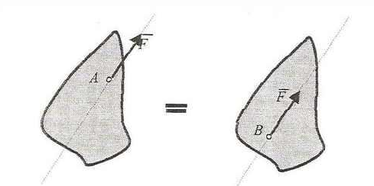
Fig. 1

Lecture 2
STATICS
The force, projection of the force on an axis
The force is defined as the action of a body about another body and it is a vector quantity. The force has four characteristic: magnitude, direction, sense and point of application.
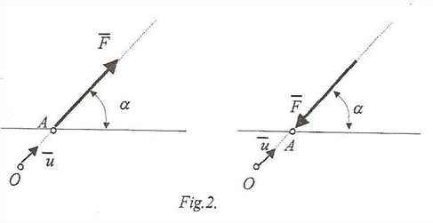 Fig. 2
If two systems of forces have the same effect about a body we shall say that the two systems are equivalent systems of forces. The reciprocal is also true, namely if two systems are equivalent than they will produce the same effect about same body.
We shall study the systems in the space with three dimensions, and the particular case of the systems in the space with two dimensions (the plane problem).
Let consider an any force, represented in the figure 3 among the points A and B and an arbitrary axis (Δ) defined with the unit vector $\overline{u}$_{Δ}.
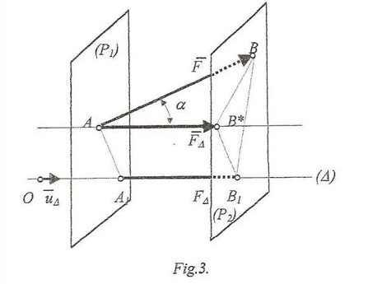
Fig. 3
Through the two points we shall consider two parallel planes (P₁) and (P₂) perpendicular on the axis (Δ). These two planes will be intersected by the axıs (Δ) in the points A₁ and B₁.
The segment of line A₁B₁ measured at the scale of the force is named projection of the force on the axis (Δ) and is marked:
A₁B₁ = pr_{(Δ)}$\overline{F}$ = F
and as we can see is a scalar quantity.
If through the point A is taken a straight line parallel with the axis (Δ) then this line will intersect the plane (P₂) in the point B* and we shall have:
A₁B₁ = AB*
But this segment of line is the side of the right angle triangle ABB* and it may be calculated resulting the expression of the projection of a force on the direction of an axis:
F_{Δ} = F⋅ cosα
If through the extremity B* we shall consider an arrowhead then AB* becomes a vector quantity that at the scale of the force has the magnitude equal with the projection of the force on the direction of the axis (Δ). This vector is called component of the force F on the direction of the axis (Δ) and can be expressed:
$\overline{F}$_{Δ} = F_{Δ}⋅$\overline{u}$_{Δ}.
We remark that the projection of a force on an axis is a scalar quantity and it may be obtained on the axis or on any parallel axis with the given axis and the component of the force on the direction of an axis is a vector quantity, has the magnitude equal with the projection of the force on the axis and has the same point of application as the given force.

Addition of two concurrent forces
Generally, when we have a system of forces, the main problem is that to transform the system in other simpler one. This is made when we can replace the system with another simpler as the first one but with the same effect about the bodies upon which are they acting. We shall start from the simplest system of forces, the system made from two concurrent forces.
Suppose two forces: $\overline{P}$ and $\overline{Q}$ having the same point of application. Using the parallelogram’s principle these two forces may be replaced with one single force having the same effect. This force marked $\overline{R}$ is called resultant force, or shortly resultant.
From mathematical point of view this resultant force is the vector sum of the two forces and we can write:
$$\overline{R} = \overline{P} + \overline{Q}$$
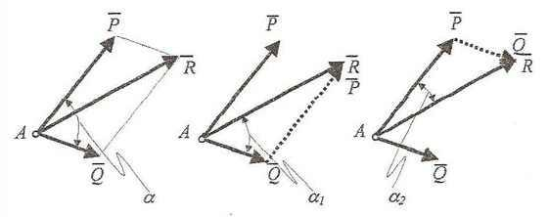
Fig. 4
The magnitude of the resultant force is obtained from the cosinus theorem in one of the two triangles that are formed in the parallelogram:
R = $\sqrt{P^{2}+Q^{2}+2PQ\cos{}}$
The direction may be obtained computing the angle between the resultant force and the direction of one force from the two using the sinus theorem in one of the two triangles made by the resultant with the two forces:
$\sin{{}_{1}= \frac{P}{R}}\sin{} ; \sin{{}_{2 }}$=$\frac{Q}{R}\sin{}$
From the parallelogram rule results another rule called triangle rule. In this rule the resultant force of the two given forces is obtained in the following way: one force, from the two, brings with its point of application in the top of the other, the resultant force resulting uniting the common point of application of the two forces with the top of the second force.
In the particular case of two collinear forces with the same sense, this last rule shows that the resultant force is obtained summing in scalar way the magnitudes of the two forces:
R = P + Q
If the two forces are collinear but with opposite senses, from the same rule, results that the resultant force has the magnitude:
R = P – Q

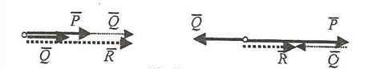
Fig. 5

Lecture 3
Moment of a force about a given point
When a force acts about a rigid body, it may be considered as a gliding vector, namely its point of application can be an arbitrary point from its support line, the force keeping the effect about the body.
At the other hand, the found expressions of the forces contain only three from the four characteristics that are: the magnitude, the direction and the sense, without to make any reference about the position of the force with respect to the body about it acts or with respect to a system of reference.
If we consider a body (for example a plane body) with a fixed point, is obviously that if the force acts in different positions about the body it will produce different effects.
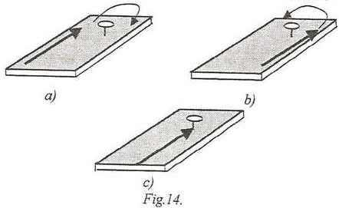
Fig. 6
For example if the force acts in the left side of the fixed point it will produce a clockwise rotation (Fig. 6a), and if the force acts in the right side of the fixed point it will produce a counterclockwise rotation (Fig. 6b), and finally if the force acts so that its support line is passing through the fixed point does not produce any rotation of the body (Fig. 6c).
These effects are obtained keeping, each time, the magnitude, direction and sense of the force. These facts make that to need to introduce a new notion for to define the position of the force with respect to any systems of reference. This new notion is called moment of the force about a given point.
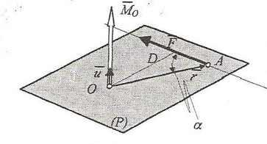
Fig. 7
Suppose a force F acting in the point A and another point O (Fig. 7). The position of the point A with respect to the point O may be defined with a vector
$\overline{OA}$ = $\overline{r}$
By definition, is called moment of the force F with respect to the point O the vector quantity, marked ${\overline{M}}_{O}$ and equal to the vector product between the position vector of the point of application of the force with respect to the given point O and the force F:
${\overline{M}}_{O}$ = $\overline{r}$ $×\overline{F}$
From the definition of the vector product results the following characteristics of the moment of the force about a point:
- The magnitude is:
$M_{O}$ = r ⋅ F ⋅ $\sin{}=F D$,
where the distance D is measured from the point O to the support line of the force F.
- The direction is perpendicular on the plane formed by the support line of the force and the point O.
- The sense of the vector moment is so that the three vectors: $M_{O}$, r and F make a right hand system, or the sense of the moment is the same as the sense of the advance of the right hand screw rotated by the force F ( the rule of the right hand).
- The point of application is the point O.

Couple
We shall define a particular system of forces. This system is called couple and by definition is the system made from two parallel forces with the same magnitudes and opposite senses.
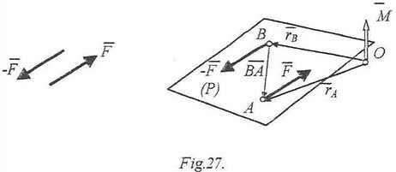
Fig. 8
This system has a particular behavior because has zero projections on the direction of any axis, namely the force effect of them is zero. So we can say that:
$\overline{R}$ = 0
At the other hand if we calculate the resultant moment of this system with respect to any point O it is obtained:
$\overline{M}$ = ${\overline{M}}_{O}\left(\overline{F}\right)$ + ${\overline{M}}_{O}\left(-\overline{F}\right)$ = ${\overline{r}}_{A}×\overline{F}$ + ${\overline{r}}_{B}×\left(-\overline{F}\right)$ = ${\overline{r}}_{A}×\overline{F}$ $-$ ${\overline{r}}_{B}×\overline{F}$ =
=$\left({\overline{r}}_{A}-{\overline{r}}_{B}\right)×\overline{F}$ =$\overline{ BA}$ $×\overline{F }$=$\overline{AB}×\left(-\overline{F}\right)$
This relations says:
- The resultant moment of a couple does not depend by the point about that is calculated. This propriety results from the fact that the final result does not refers about the point O. Consequently the moment of a couple is a free vector.
- The moment of the couple may be calculated as the moment of one force (from two) about a point from the other force.
The moment of the couple being a vector quantity is defined by the following characteristics: the magnitude is equal to the magnitude of the force multiplied with the distance between the support lines of the two paralel forces:
M = F $∙$ D
The direction of the moment of the couple is perpendicular on the plane containing the two forces; the sense is determined with the right hand rule or the
right screw rule; the point of application can be any point from space because
the moment of the couple is a free vector.

Varignon’s theorem
This theorem says: for a system of concurrent forces the resultant moment of the system, calculated about a point, is equal to the moment of the resultant force of the system about the same point:
$$Σ{\overline{M}}_{O}\left({\overline{F}}_{ı}\right)= {\overline{M}}_{O}\left(\overline{R}\right)$$
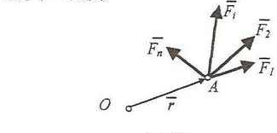
Fig. 9
For to prove we have:
${\overline{M}}_{O}\left({\overline{F}}_{ı}\right)=Σ \overline{r}×{\overline{F}}_{ı}= \overline{r}×Σ{\overline{F}}_{ı}=\overline{r}×\overline{R}={\overline{M}}_{O}\left(\overline{R}\right)$

Lecture 4
Reduction of a force in a given point
When a force acts about a body it produces a mechanical effect (usual it produces a motion that generally is a combination of a translation and a rotation). The determination of the mechanical effect of a force in a given point of the body about that the force is acting is called reduction of the force in that point.

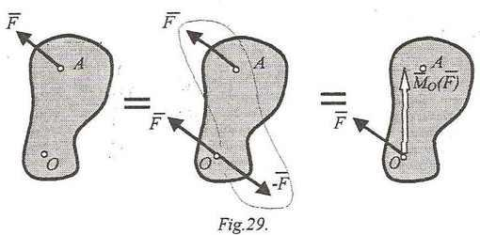
Fig. 10
Suppose that in the point A of a body acts a force $\overline{F}$ and we want to determine its mechanical effect in the point O. For this we shall make an artifice but without to modify the mechanical effect of the force about the body.
In point O we shall introduce a system of forces equivalent with zero (without effect about the body) made from two forces having the same magnitudes and opposite senses. This system does not modify the mechanical state of the body.
Now if we consider together the force $\overline{F}$ from the point A and the force $-\overline{F}$ from the point O, then these two forces make a couple, that being a free vector may be considered acting in point O. The moment of this couple is, as we have seen, equal to the moment of one force, from the two, about a point from the support line of the other force, here we shall consider the point O. In this way we may consider that we have transformed the body acted by the force $\overline{F}$ from A in the body acted by the force $\overline{F}$ acting in O and a moment equal to the moment of the force $\overline{F}$ from A about the point O, without to modify the mechanical state of the body.
The ensemble made from the two vectors: $\overline{F}$ in O and the moment of the force about the point O is called force-couple system of the force $\overline{F}$ in point O.
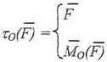
We can state that the force $\overline{F}$ and its force-couple system in a point are equivalent (they produce the same effect about the body).
Reduction of a system of forces in a given point
To consider now a system of any forces acting about a rigid body. We shall determine the mechanical effect of this system in point O. For this we shall replace each force with the corresponding force-couple system in point O.
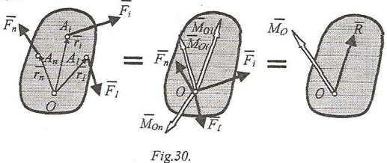
Fig. 11
In this way we have transformed, without to modify the mechanical state of the body, the given system of forces in two systems of concurrent vectors: the first is the system of the given forces but acting all in point O and the second the system of the moments of the given forces calculated about the point O. The simplest equivalent systems of these two systems of vectors are two vectors: the resultant force of the forces from the given system of forces (considered acting all in the same point) and the resultant moment of the forces from the given system of forces calculated about the point O. The ensemble of these two vectors form the force-couple system in point O of the given system of forces and it has the expression:
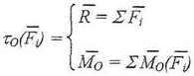
We may state that: a system of forces is equivalent to its force-couple system in a point, and also that two systems of forces with the same force-couple system in the same point are equivalent systems of forces.
If we change the point of reduction, (for example the point A) and performing the same steps is obtained the force-couple system in point A:

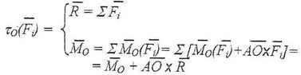
Lecture 5
Systems of coplanar forces
We shall analyze some particular systems of forces. One of this kind of system is the system of coplanar forces, that is defined as the system of forces made from forces lying in the same plane.
We shall suppose that the plane in which is located the system is the xOy plane.
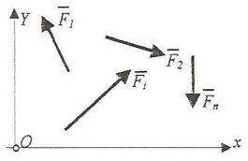
Fig. 12
An any force from the system has the expression in this reference system
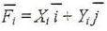
and the moment of this force about the origin of the reference system will be
With these the force-couple system in point O has the components:
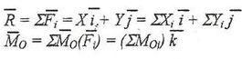
We can see that the two vectors are perpendicular and the scalar product of them is equal to zero:
The cases of reduction of these kinds of systems of forces are:
- $\overline{R}=0$; ${\overline{M}}_{o}=0$. The system of forces is in equilibrium. The two vector equations will give us three scalar conditions of equilibrium:
- $\overline{R}=0$; ${\overline{M}}_{o}≠0$. The system of forces reduces to a couple. This couple may be represented or as a system made from two parallel and opposite forces having the same magnitude, or as the moment of the couple defined by the sense and magnitude.
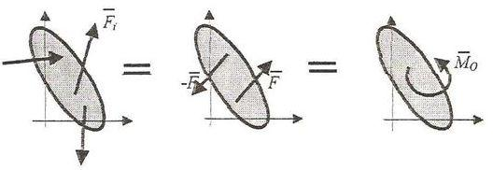
Fig. 13
- $\overline{R}≠0$; ${\overline{M}}_{o}=0$. In this case the simplest equivalent system is the unique resultant force passing through the point O.
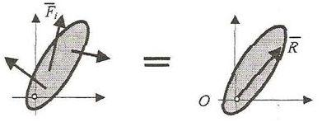
Fig. 14
- $\overline{R}≠0$; ${\overline{M}}_{o}≠0$ and $\overline{R}∙{\overline{M}}_{o}=0$ namely the system of forces reduces to an unique resultant force that does not pass through the point O. In this case we have to determine the position of the unique resultant force that is the simplest equivalent system.
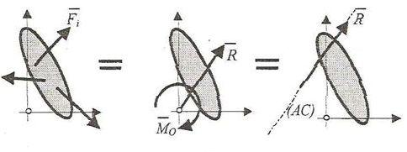
Fig. 15

Systems of parallel forces. Center of the parallel forces
An other particular system of forces is the system of paralel forces, that is made from forces with parallel support lines. Suppose that the support lines of the forces are parallel with the axis Oz (we may take arbitrary reference system, but for simplifying the calculation we choose the axis Oz parallel with the common direction of the forces).
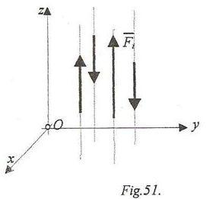
Fig. 16
One force from the system will have expression with respect to this reference system
and the moment of this force about the origin of the reference system O will be:
Making the reduction of the system of forces in point O we shall obtain:
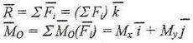
We remark that, the two vectors are perpendicular, so we have:
$$\overline{R}∙{\overline{M}}_{o}=0$$
In the case $\overline{R}≠0$; ${\overline{M}}_{o}≠0$ the system is reduced to an unique resultant force that does not passé through the point O.
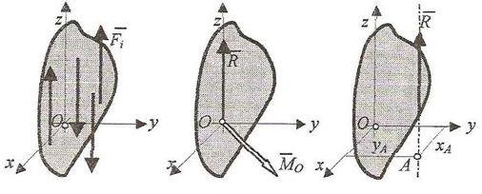
Fig. 17
Consequently we have to determine the position of this force using the equation of the central axis. This equation becomes for the parallel forces with the Oz axis:
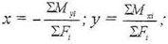
We may remark that these two equations define, with z=0, the coordinates of the intersection point between the support line of the resultant force and the xOy plane (the point A).
An important particular case of parallel forces is that when the forces are fixed vectors. This means that the forces of the system have the defined points of application.
At this kind of systems we may state two important proprieties:
1) If the forces of the system of parallel forces are fixed vectors then the unique resultant force of the system (if it exists) is fixed vector too. The point of application of this resultant force is called center of parallel forces.
2) If the forces of the system of parallel forces rotate with the same angle about their points of application (the system remaining with paralel forces) then the unique resultant force (if it exists) rotates with the same angle about the center of the parallel forces.
We shall use these two proprieties for to find the center of the parallel forces.
Let be a system of parallel forces, fixed vectors, which is reduced to an unique resultant force. For this kind of system we may write the Varignon’s theorem, namely:
or expressing the moments:
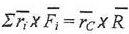
Considering the forces parallel with Oz axis and bringing the both terms of this relation in the left part, results:
We know that the scalar quantities $F_{i}$ and R may multiply any vector of the vector product, and if we replace the magnitude of the resultant force with the sum of the magnitudes of the forces, the relation is transformed in:
Now, we shall take out the common vector k from the parenthesis and it is obtained:
This vector product may be zero in three cases: if one of the two vectors is equal to zero, or if the two vectors are collinear. But the second vector is an unit vector so it is different as zero. At the other hand if the two vectors (the parenthesis and k) are collinear, using the second property of these kind of forces , the system may be rotated with an any angle and they will be not collinear, so in this case they does not annul the relation. Consequently the single case when this relation will be zero is then the parenthesis is equal to zero. Results:
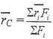
And finally, projecting on the axes of the reference system, result the coordinates of the center of parallel forces:
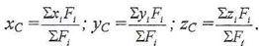

Lecture 6
Centers of gravity
A particular case of parallel forces, fixed vectors is the system of the gravitational forces.
If the bodies, or the systems of particles, have small dimensions with respect to the radius of the Earth and they are located in the neighborhood of the Earth’s surface then they can be considered acted by the parallel forces, these being the attraction forces exerted by the Earth about them and called weight. These forces may be expressed function the masses of the bodies:
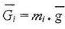
where g is the gravitational acceleration vector that can be considered constant in magnitude, direction and sense. The magnitude of this acceleration will be taken in the usual problems $g=9,81 \frac{m}{s^{2}}$
To suppose a system of particles $A_{i}$ by the masses $m_{i}$ and a system of reference Oxyz. The weights of these particles considered as paralel forces, acting all in the same sense will have a resultant force, the total weight of the system of particles, as fixed vector with the point of application (the center of the parallel forces) called center of gravity.
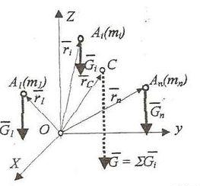
Fig. 18
In accordance with the previous theme, the position of the center of gravity will be obtained with the relation:
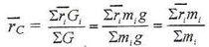
As we can see, the center of gravity is located in the same point with the center of mass, for the systems satisfying the previous conditions.
To consider now a rigid body. A rigid body may be considered a continuous system of particles namely a system of infinitesimal masses dm called elementary masses tending to zero as magnitude. The number of these elementary masses tends to infinity. Each such element will be acted be an elementary weight:
Using the same relations but in which we replace the finite sum with the infinite sum, namely the integral, we find the position of the center of gravity for the rigid body:
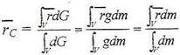
The coordinates of this center for the rigid body are:
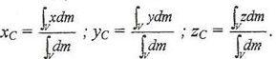

Statics of the particle
By definition the particle is a body with very small dimensions (that can be neglected) or a body at which the dimensions are not interested in the studied problem. If the particle may have any position in space we say that it is a free particle. But if the particle cannot have any position in space, due to restrictions of geometrical nature, we say that it is a constrained particle or a restricted particle.
Consider a free particle. The position of it may be expressed with an any reference system using three scalar coordinates named generally position parameters. If the particle is free it may have any position in space, so the position parameters can modify their values independently one with respect to the others and these parameters will be independent position parameters.
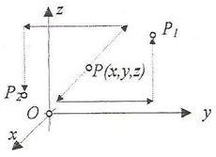
Fig. 19
At the other hand for to change the position of the particle from an any position to another any position (for example ${\overline{P}}_{1}$ and ${\overline{P}}_{2}$) we may perform three particular independent motions. Independent possibilities of motion of the particle for to modify its position are called degrees of freedom. We remark that a free particle in space has three degrees of freedom and this number is equal to the number of the independent scalar position parameters.
In plane problems (in two dimensions) the position of the particle is defined by two position parameters and for to change its position we have to make two independent motions, consequently the particle has two degrees of freedom in plane.
The previous relationship, if it remains true for the constrained particle, shows us that for to determine the number of the degrees of freedom we have two ways: or we determine the number of the independent scalar position parameters, or we determine the number of the independent possibilities of motion for to change its position.
Let be a free particle in rest. We shall consider that about the particle is acting a system of concurrent forces. The problem is the following: under what conditions the particle in rest will remain in rest under the action of the concurrent system of forces? Because the particle is in rest is obviously that the system of forces must have zero effect about the particle. But because the simplest equivalent system of the given system of forces is the resultant force we have the condition:
$$\overline{R}=0$$
that is the vector condition for that the particle to remain in rest. In the same time, the state when the system of forces is equivalent to zero is called equilibrium. So for a particle to remain in rest the system of forces must be in equilibrium. We shall say that the particle is in equilibrium. The scalar conditions of equilibrium of the particle will be:
Function of the nature of the unknowns of the problem we distinguish three kinds of problems:
- The direct problem in which are known all forces that act about the particle and is asked the equilibrium position. Because the equilibrium position is defined by three scalar independent position parameters, and the number of the scalar equilibrium conditions is three also, the problem has
unique solution.
- The inverse problem in which is known the equilibrium position of the particle and is asked the system of forces that give us that position. Generally this kind of problems has an infinity number of solutions.
- The mixed problem is the problem in which we know a part from the scalar position parameters and a part from the forces acting about the particle and is asked to determine the other part of the position parameters and forces for to have equilibrium of the particle.
By definition any geometrical restriction requires to the particle in the possibility of change its position is called constraint. We remark that the constraints remove degrees of freedom of the particle. The constraints which remove one degree of freedom are called simple constraints, and those which remove more degrees of freedom are called multiple constraints. Any constraint may be replaced with a force called reaction force without to change the state (of rest) of the particle.
If we decompose the reaction force R in two components: one on the normal direction to the tangential plane in the connection (on the direction of the removed displacement by the constraint) and one in tangential plane, then we may write:
where $\overline{N}$ is called normal reaction force and $\overline{T}$ is called friction force. Depending on the existence or not of the friction force we have two kinds of constraints: ideal constraint (without friction force):
namely the reaction force is the normal reaction force and real constraint (with friction).
To suppose that a particle is acted by a system of concurrent forces and has some ideal constraints. We shall see to find the conditions in which the particle in rest remains in rest under the action of the forces and the constraints.
For to determine these conditions, first, using the axiom of the constraints we shall remove the ideal constraints with the corresponding reaction forces. The reaction force of a simple ideal constraint will have the following characteristics:
- The magnitude is unknown. It will be determined from the conditions to keep the initial state of the particle. In this case the initial state is the rest, or for the forces the equilibrium.
- The direction of the reaction force is normal on the tangential plane to the surface representing the constraint. This direction is that of the removed displacement by the simple constraint, consequently the direction of the reaction force is known.
- For the unilateral constraints the sense of the reaction force is inversely as the sense of the removed displacement, and for the bilateral constraint the sense is unknown. But this is not an independent unknown because on a direction there are only two senses, and for to determine the true sense we shall choose a sense (arbitrary) and from computation will results the sense of the reaction force as sign of the magnitude (the sign plus meaning that we sense is the chosen sense and the sign minus meaning that the reaction force has opposite sense).
- The point of application is the particle.
We may remark that a simple constraint removes one degree of freedom but introduces in calculation one scalar unknown, the magnitude of the reaction force. Because a simple constraint eliminates one independent, scalar position parameter, in fact a simple constraint does not change the number of the unknowns, it changes only the nature of the unknown, in place of a scalar position parameter we have as unknown a force (the reaction force). Using the axiom of constraints the particle becomes a free particle acted by two kinds of forces: one a system of given forces (active forces, loads) and the other a system of reaction forces (passive forces). The condition as this particle to be in rest, or in equilibrium, is that:
${\overline{R}}_{g}$ + ${\overline{R}}_{r}$ = 0
where we have marked ${\overline{R}}_{g}$ the resultant force of the given forces and ${\overline{R}}_{r}$ the resultant force of the reaction forces. The scalar conditions of equilibrium are:
$$\sum{X_{gi}+\sum{X_{rj}=0}}$$
$$\sum{Y_{gi}+\sum{Y_{rj}}=0}$$
$$\sum{Z_{gi}}+\sum{Z_{rj}=0}$$
As for the free particle we have three kinds of problems: direct problem, inverse problem and mixed problem.
Lecture 7
Statics of the rigid body
The rigid body is the non-deformable body namely the body at which the distance among two any points remains unchanged indifferent to the actions about it.
If the body may have any position in space we have a free rigid body. But if the body cannot have any position in space because restrictions imposed to its points then it is a constrained body.
Suppose a free rigid body. For to define the position a free body with respect to a system of reference we shall make in the following way: first we define the position of one point from the body, for example the point A (in fact we fix this point).
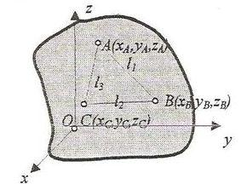
Fig. 20
We see that if we fix a point from the body, the body is not fixed because it has possibilities to rotate about this point without to modify the coordinates of this point (the position parameters of the point). We shall define the position of another point from the body in fact we fix another point B at the distance $l_{1}$ from A. We see again that the body is not fixed because it may perform a rotation about the straight line passing through these two points. Consequently we shall consider defined (fixed) the third point using its coordinates and the two distances $l_{2}$ and $l_{3}$ with respect to the other two points and we see that in this case the body is completely defined in a unique position in space. Finally we may say that the position of a free body in space is defined through three points namely through nine scalar independent position parameters (the nine coordinates of the three points with respect to the chosen system of reference).
But between these nine coordinates and the three distances between the three points we have the following three relationships:
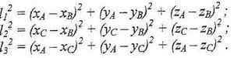
From all these results that the position of a free body is defined by six scalar independent position parameters.
Suppose now a body in an any position. For to change its position (from an any position in another any position) there are six independent possibilities of motion namely three translations parallel to the three axes of the system and three rotations about three axes parallel to the axes of the system of reference. We have defined the independent possibilities of motion as degrees of freedom, so the free rigid body has six degrees of freedom.
Let to consider now the plane problem of the rigid body (the body in two dimensions). We can see that the position of the body is defined completely defining the position of two points of the body. Knowing the mutual positions of the two points (the distance l) we may write:
resulting that the position of a free rigid body in plane is defined by three scalar independent position parameters. If we want to change the position of the body we have three independent possibilities of motion (two translations parallel to the axes of a system of reference and a rotation about a point). We say that the rigid body in
plane has three degrees of freedom.
Now, suppose a free rigid body in rest. We want to find the conditions in which the body remains in rest under the action of a system of forces. This may be obtained if the system of forces has zero effect about the body. We have seen that for a system of forces to have no effect about a body it has to be in equilibrium. We shall say in this case that the rigid body is in equilibrium. The conditions of equilibrium are:
or:
The scalar conditions of equilibrium are obtained projecting the previous vector equations on the axes of a convenient system of reference:
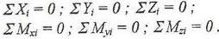
In plane problem (in two dimensions) when the body is acted by a system of coplanar system of forces in the plane of the body these conditions are:
namely we shall use two equations of forces and one moment equation.

Statically determined and stable rigid body
The intention to use the constraint is to fix the body. In this part of the theoretical mechanics we shall use the constraint for to fix the bodies but, this have to make so that using the equilibrium equations to can determine the reactions from the constraints. We shall say that if a body is fixed and has in the constraints the same number of scalar unknowns as the number of the scalar independent equilibrium equations the body is statically determined and stable. Consequently the statically determined and stable body checks two conditions.
The first is that:
N_{E} = N_{U}
where N_{E} is the number of the scalar independent equilibrium equations and N_{U}
is the number of the scalar unknowns in the constraints of the body. The second is: the rigid body to be fixed by its constraints. In fact the first condition is a quantitative condition namely the number of equations to be the same as the
number of the unknowns, and the second is a qualitative condition as the system
of equations to be compatible.
Knowing that for a free rigid body in plane we can write only three scalar independent equilibrium equations we shall show the immobilization schemes of the rigid body in plane.
Using only simple supports and knowing that one simple support removes one degree of freedom and introduces in computation one scalar unknown, for to fix the body we need three simple supports.
If we want to fix a body using only hinged supports we see that one hinge doesn’t fix the body and two hinges fixes the body but have four unknowns in them. In this way we shall combine one hinged support with a simple support obtaining a fixed body with three unknowns in the constraints.
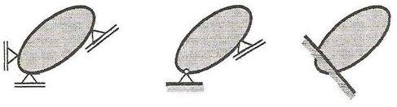
Fig. 21
Finally the body may be fixed with one fixed support that introduces in equations three unknowns.
If between the number of the equations and the number of the unknowns is the relation N_{E} < N_{U} , then the body is said to be a statically non-determined body. If there is the relation N_{E} > N_{U}, then the body remains with degrees of freedom and we say it is a mechanism.
There are cases when the quantitative condition is checked but the qualitative condition doesn’t, the body keeping degrees of freedom. These cases are called critical forms. possibilities of motion possibilities of motion
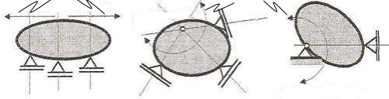
Fig. 22
The first case of critical form is that when the three simple supports have parallel directions. We remark that the possibility of translation on the normal direction on the directions of the simple supports is not blocked by the constraints.
Another critical form is obtained when the directions of the three simple supports are concurrent in the same point. Knowing that the displacements of the points of a rigid body in a rotation about a point are perpendicular on the radii from the rotation center, the three simple supports don’t prevent these displacements, so the body keeps the possibility of rotation about that point.
Finally another critical form is obtained if the direction of the simple support passes through the hinge because in this case the body keeps the possibility of rotation about the hinge.
It is obviously that the fixed support doesn’t produces critical form.

Lecture 8
Loads
The loads are active systems of forces (generally given systems of forces) that act the bodies. Depending by the way of action about the bodies we have two kinds of loads: concentrated loads and distributed loads. Also the loads can be: forces or moments (couples).
- Concentrated force. Is a force that acts in a point on the rigid body. This force has force effect and moment effect also calculated as in the previously chapters.
- Concentrated moment. Is the load equivalent to a system of forces reduced to a couple. This load acts in a point about the rigid body and it is represented as in the Fig. 23. because for the rigid body the moment of a couple is a free vector, in the problems involving rigid bodies doesn’t interested its point of application. The main characteristic of this load is that it has not force effect (it is not considered in the projection equations) and the moment effect is the same about all points in plane (so in each moment equation will have the same value and the same sign).

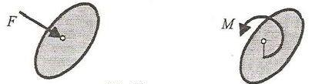
Fig. 23
For the distributed loads we shall show only the distributed forces. These forces are classified by function of the law of distribution. For example in the figure 24 is represented a uniformly distributed force, vertical action, having p as its intensity, distributed on the horizontal length l.
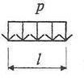
Fig. 24
Being a system of forces, the uniformly distributed force can be replaced with a resultant force having as magnitude the product between the intensity of it and the length of distribution:
$$R=p∙l$$
The direction and the sense of the resultant is the same of the components of the system and the position is in the middle of the distribution length.

Steps to solve the reactions from the constraints of a statically and stable rigid body

In the solution of a problem in which we determine the reactions from the constraints of a statically and stable rigid body are passed the following steps:
- We check if the body is or not statically determined and stable, namely it has or not three unknowns in the constraints and it is fixed or not;
- We remove the constraints with the corresponding reactions;
- We arrange the loads, namely the forces are divided into two components on the convenient directions (generally on horizontal and vertical directions) and the distributed forces are replaced with the corresponding resultant forces. Finally we shall obtain a free rigid body acted by concentrated forces and couples (a part of them known forces and couples – the loads and the other part unknown forces and couples – the reactions) representing the free body diagram;
- We write three equilibrium equations. If the body has not fixed support then we prefer to write two moment equations about two constraints and one projection equation but if the body has fixed support we prefer to write two projection equations and a moment equation about the fixed support;
5)We solve the system of the three equations resulting the reactions from the constraints. These reactions are represented , with the real senses, on the scheme representing the free body diagram;
6)We check the solution writing one equation non-used for the solution.

Lecture 9
Subject of the strength of materials. Basic hypothesis and principles
Nowadays the building of machines and other engineering structures is impossible without projects previously drawn. The project consists of the drawings and explanation notes presenting the dimensions of the construction elements, the materials and the technology necessary for their production. The dimensions of the elements and details depend on the characteristics of the used materials and the external forces acting upon the structures and they have to be determined carefully during the design procedure.
The construction must be reliable as well as economical during the exploitation process. The reliability is guaranteed when the definite strength, stiffness and stability are taken in mind in the construction. The economy of the construction depends on the material’s expenditureand it is obvious that the reliability and the economy are opposite requirements. Because of that, the Strength of Materials relies on the experience as well as the theory and is a science in development.
Strength is the ability of the construction to resist the influence of the external forces acting upon it.
Stiffness is the ability of the construction to resist the strains caused by the external forces acting upon it.
Stability is the property of the construction to keep its initial position of equilibrium.
Strength of Materials widely relies on the Theoretical Mechanics, Mathematics and Physics. Besides, it is the basis of the other subjects in the engineering practice.
The basic problem of this science is development of engineering methods to design the construction elements applying the restraining conditions about the strength, stiffness and stability of the structure when the definite economy is given.
To examine the real object a correct corresponding computational scheme must be chosen. The computational scheme is a real body for which the unessential attributes are eliminated. To choose the correct computational scheme the main hypotheses and principles of Strength of materials have to be introduced.
Hypothesis of the material continuity: The material is uniformly distributed in a whole body volume.
Hypothesis of the material homogeneity: All points of the body have the same material properties.
Hypothesis of the material isotropy: The material properties are the same in each direction of a body.
Hypothesis of the deformability of the body: Contrary to the Theoretical Mechanics studying the rigid bodies, Strength of Materials studies the bodies possessing the ability to deform, i.e. the ability to change its initial shape and dimensions under the action of external forces. The deformations at each point are assumed to be small relative to the dimensions of construction. Then, their influence onto the mutual positions of the loads can be neglected (the calculations will be made about the undeformed construction).
Hypothesis of the elasticity: Elasticity is the ability of the body to restore its initial shape and dimensions when the acting forces have been removed.
Hypotheses about the shape of the body: The basic problem of Strength of Materials is referred to the case of the beam type bodies. The beam is a body which length is significant bigger than the cross-sectional dimensions.
Hypothesis of the planar cross-sections (Bernoulli’s hypothesis): Each planar cross-section normal to the axis of the beam before the deformation remains planar and normal to the same axis after deformation.
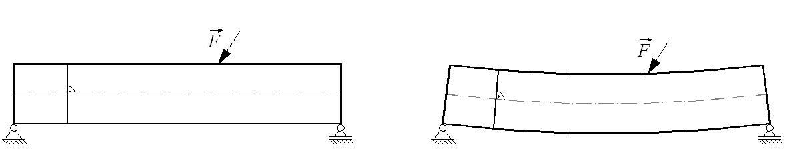
Fig. 25
Hypotheses about the applied forces: The distributed upon a small area loads are assumed to be concentrated.
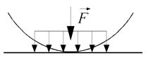
Fig. 26
Principle of Saint-Venant: If we replace a set of forces acting upon an area Ω₁ of the deformable body with other set of forces equivalent to the first one, but acting upon the area Ω₂ of the same body, the replacing will influence on the stresses and deformations in the area Ω , containing Ω₁ and Ω₂, where the influence’s magnitude will correspond to the size of the bigger area between Ω₁ and Ω₂.
Hypothesis of the local equilibrium: If the body is in equilibrium, then, each part of the body is also in equilibrium.
Hypothesis of the statical action of the forces: The magnitude of the applied external forces increases gradually from zero to the final value.
Hypothesis of the initial and final position of equilibrium: Let the initial position of the beam to be the position of equilibrium. If the applied external forces cause the small deformations according to the hypothesis studied earlier, the final position of the beam is also position of equilibrium. Then, investigating the beam, the assumption that the initial position of equilibrium coincides with the final one is made.
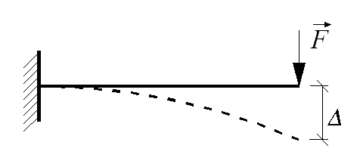
Fig. 26
Principle of superposition: The final magnitude of a quantity considered (stress, strain, displacement, rotation) caused by the set of external forces can be obtained as an algebraic sum of the quantity magnitudes caused by the particular forces composing the set.
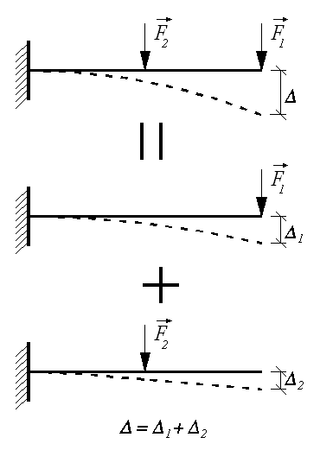
Fig. 27

Principle of hardening: A body has a definite shape and dimensions before loading. The same body has the definite shape and dimensions after loading, again, but they are different than the first ones.
Rigid body – a body consisting of particles the distances between which do not change. Deformable body – a body consisting of particles the distances between which change. A deformable body is a rigid one only to the definite loading.

Definition of internal forces. Method of section
A beam in equilibrium under the action of a set of forces is considered. This set of forces causes the deformation of the beam where the distances between the beam points change. Then, the forces of interaction between the points also change. The additional forces of interaction arising in the body are named internal forces. They have to be studied because they are related to the resistance of the body against the applied loads, and, consequently, to the strength of the body. The internal forces are the measure of interaction between two body parts situated on the two sides of the same section.
The internal forces can be determined by the method of section, as follow: Let the beam in Fig. 28 to be in equilibrium under the action of a set of forces ${\overline{F}}_{1}$, ${\overline{F}}_{2}$, ... ${\overline{F}}_{n}$, named external forces.
Fig. 28

They include the external loads as well as the support reactions previously obtained. A plane normal to the longitudinal axis of the beam divides the body into two parts. A border section between these two parts is called the cross-section.
Further, one of the parts is removed (usually that one upon which the bigger number of loads acts) while the other will be investigated.
Fig. 29
The hypothesis of the local equilibrium has the essential role in Strength of materials and according to it, if a body is in equilibrium, then each part of the body is in equilibrium, too. This hypothesis leads to the conclusion that the left part of the beam must be in equilibrium under the action of a set of forces applied on it. However, the external forces are not in equilibrium themselves. To be the left beam part in equilibrium, the new type of forces must be introduced. These additional forces are the internal forces in the beam and they give the influence of the right beam part on the left one.
If the right beam part is chosen for investigation, then the internal forces giving the influence of the left beam part on the right one have to be put. According to the Newton’s third law, the internal forces acting upon the left beam part and these ones acting upon the right beam part must have the same magnitudes, same directions and opposite senses.
The internal forces points of application in the plane of the cross-section are infinite as number and, because of that, they can not be found strictly. Then, to determine their magnitudes, the method known by Theoretical mechanics will be used, as follow: reduction of the set of internal forces will be made about the cross-section’s center of gravity where the main vector $\overline{R}$ and the main moment $\overline{M}$ will be obtained.
In a spatial case of loading when the left beam part is considered, the origin of the coordinate system is the center of gravity of the cross-section. The axis x is normal to the cross-sectional plane and its positive sense is out of the section. The axes y and z belong to the cross-sectional plane where the z – axis has the downward direction while the y – axis has the sense so that the three axes form the right-handed Cartesian coordinate system.
Fig. 30
The internal forces in the spatial case of loading are six and they are labeled in the following manner:
${ R}_{x}$=N - axial (normal) force; $M_{x}$=T - torsion moment;
${ V}_{z}$ - shearing force onto z – axis; My - bending moment about y – axis;
${ V}_{y}$- shearing force onto y – axis; Mz - bending moment about z – axis.
If the external forces acting upon the beam are situated in the plane containing the beam axis, then the loading case named planar is simpler: only the axes x and z have to be introduced in the cross-section’s center of gravity. Now, the internal forces are three:
N - axial (normal) force; V - shearing force; M - bending moment.
The internal forces must be introduced always with their positive senses, which for the left and right beam part are given in Fig. 31:
Fig. 31
The axial force N is supposed to be positive when its sense is out of the section.
The shearing force V is supposed to be positive when its sense coincides with the sense of the positive axial force rotated at an angle of 90⁰ in clockwise direction.
The bending moment is supposed to be positive when the curved arrow represented the moment begins from the downer beam end and finishes in the upper one without crossing the beam.
It is important to note, that the concept of internal forces always relates to the definite beam section.

Lecture 10
Stress at a point. Strain
A deformable body loaded by forces is in equilibrium. In order to investigate internal forces the body is divided into two portions by imaginary plane and the selected portion is examined. Influence of another body portion on the selected one is accounted for the internal forces reduced about the cross-sectional center of gravity. Thus, the internal forces are defined as concentrated forces and moments.
Actually, the internal forces are distributed and their magnitudes are not constants in the cross-sectional area. Therefore, it is necessary to introduce the concept of stress which will characterize the law of distribution of internal forces.
The concept of stress was introduced in 1822. Stress is the intensity of the internal forces distribution on the small area around the point of the deformable body.
Fig. 32
The average stress on the area can be described by the expression
${\overline{p}}_{av}$=$\frac{\overline{∆R}}{∆A}$
It is well-known that the material building the body is distributed uniformly in the whole volume of the body. Thus, the limit transition $∆$A$→$0 can be used. Then, stress on the area of normal n around point K is
${\overline{p}}_{n}$=$\lim_{∆A→0}{\frac{\overline{∆R}}{∆A}}$
The International Sistem unit for stress is Pascal (symbol Pa) which is equivalent to one newton (force) per square meter (unit area): 1 Pa=1$\frac{N}{m^{2}}$.
Fig. 33
The stresses on the different planes passing through the point considered are different. Let $α$ to be the angle between stress p_{n} and the cross-sectional normal n. Then,
$σ_{n}=p_{n}\cos{α}$ is the normal stress on the plane of normal n,
$τ_{n}=p_{n}\sin{α}$ is the shearing stress on the plane of normal n.
It is evident that
$$p_{n}=\sqrt{σ_{n}^{2}+τ_{n}^{2}}$$
The state of stress at point K represents a sum of all stresses onto all possible planes passing through the point.
The investigation on the state of stress gives a possibility to analyze the strength of material when the random loading acts upon the body.
Each loaded body is deformed. Its form and sizes are changed because the points of the body change their position. During deformation, the material of the body resists the tendency of the load to deform the body, and when the load influence is taken over by the internal resistance of the material of the body, it becomes stable. This internal resistance which the body offers to meet with the load is called stress. Any element in a material subjected to stress is said to be strained. The strain is the deformation produced by stress.
The various types of strains may be classified as:
- Simple or direct stress (Tension-Compression; Shear).
2. Indirect stress (Bending; Torsion).
3. Combined stress. Any possible combination of types 1 and 2.
In this course we will deal with simple and indirect stresses only.

Normal Stress. Hooke's Law

Tensile stress – stress that tends to stretch or lengthen the material – acts normal to the stressed area.

Compressive stress – stress that tends to compress or shorten the material – acts normal to the stressed area.

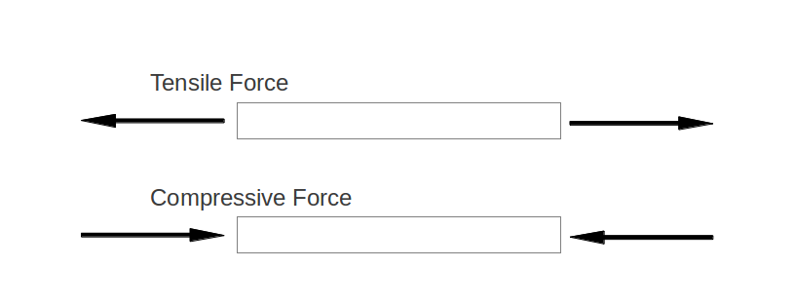
Fig. 34
Clearly it is important to avoid deformations so large that they may prevent the beam from fulfilling the purpose for which it is intended.
Consider a rod of uniform cross section with initial length L₀ as shown in Fig. 35.

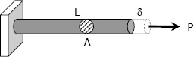
Fig. 35
Application of a tensile load P at one end of the rod results in elongation of the rod by $σ$. After elongation, the length of the rod is L. As the cross section of the rod is uniform, it is appropriate to assume that the elongation is uniform throughout the volume of the rod. If the tensile load is replaced by a compressive load, then the deformation of the rod will be a contraction. The deformation per unit length of the rod along its axis is defined as the normal strain. It is denoted by ε.
$$ε=\frac{δ}{L_{0}}=\frac{L-L_{0}}{L_{0}}$$
The normal strain is a dimensionless quantity.
Most metals deform proportional to imposed load over a range of loads. Stress is proportional to load and strain is proportional to deformation as expressed with Hooke's law.
$σ=E∙ε$
Modulus of Elasticity, or Young's Modulus, is commonly used for metals and metal alloys and expressed in term Pa.
Consider a rod under an axial tensile load P as shown in Fig. 35 such that the material is within the elastic limit. The normal stress on x plane is $σ_{x-x}=\frac{P}{A}$ and the associated longitudinal strain in the x direction can be found out from $ε_{x}=\frac{σ_{x-x}}{E}:$
$$δ=\frac{P∙L_{0}}{E∙A}$$
As the material elongates in the x direction due to the load P, it also contracts in the other two mutually perpendicular directions, i.e., y and z directions.
The ratio between the lateral strain and the axial (longitudinal) strain for a given material is always a constant within the elastic limit and this constant is referred to as Poisson's ratio. It is denoted by $ν$.
$$ν=-\frac{lateral strain}{axial strain}$$
Since the axial and lateral strains are opposite in sign, a negative sign is introduced in previous equation to make ν positive. The lateral strain in the material can be obtained by
$$ε_{y}=ε_{z}=-ν∙ε_{x}$$
Poisson's ratio can be as low as 0,1 for concrete and as high as 0,5 for rubber. In general, it varies from 0,25 to 0,35 and for steel it is about 0,3.

Lecture 11
Stress-strain Diagram
Suppose that a metal specimen be placed in tension-compression-testing machine. As the axial load is gradually increased in increments, the total elongation over the gauge length is measured at each increment of the load and this is continued until failure of the specimen takes place. Knowing the original cross-sectional area and length of the specimen, the normal stress σ and the strain ε can be obtained. The graph of these quantities with the stress σ along the y-axis and the strain ε along the x-axis is called the stress-strain diagram. The stress-strain diagram differs in form for various materials. The diagram shown below is that for a medium-carbon structural steel.

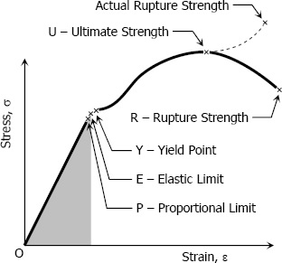
Fig. 36
Metallic engineering materials are classified as either ductile or brittle materials. A ductile material is one having relatively large tensile strains up to the point of rupture like structural steel and aluminum, whereas brittle materials has a relatively small strain up to the point of rupture like cast iron and concrete.
Proportional Limit (Hooke's Law)
From the origin O to the point called proportional limit, the stress-strain curve is a straight line. This linear relation between elongation and the axial force causing was first noticed by Sir Robert Hooke in 1678 and is called Hooke's Law that within the proportional limit, the stress is directly proportional to strain.
The constant of proportionality is called the Modulus of Elasticity E or Young's Modulus and is equal to the slope of the stress-strain diagram from O to P.
Elastic Limit
The elastic limit is the limit beyond which the material will no longer go back to its original shape when the load is removed, or it is the maximum stress that may e developed such that there is no permanent or residual deformation when the load is entirely removed.
Elastic and Plastic Ranges
The region in stress-strain diagram from O to P is called the elastic range. The region from P to R is called the plastic range.
Yield Point
Yield point is the point at which the material will have an appreciable elongation or yielding without any increase in load.
Ultimate Strength
The maximum ordinate in the stress-strain diagram is the ultimate strength or tensile strength.
Rapture Strength
Rapture strength is the strength of the material at rupture. This is also known as the breaking strength.
Working Stress, Allowable Stress, and Factor of Safety
Working stress is defined as the actual stress of a material under a given loading. The maximum safe stress that a material can carry is termed as the allowable stress. The allowable stress should be limited to values not exceeding the proportional limit. However, since proportional limit is difficult to determine accurately, the allowable stress is taken as either the yield point or ultimate strength divided by a factor of safety. The ratio of this strength (ultimate or yield strength) to allowable strength is called the factor of safety.

Shear Stress
Shear strain is the strain resulting from the application of opposing forces in a direction parallel to a surface or to a planar cross section of a body.
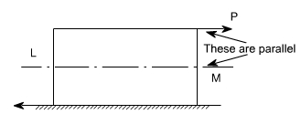
Fig. 37
If the applied load P consists of two equal and opposite parallel forces not in the same line, than there is a tendency for one part of the body to slide over or shear from the other part across any section LM. If the cross section at LM measured parallel to the load is A, then the average value of shear stress τ = P/A. The shear stress is tangential to the area over which it acts.
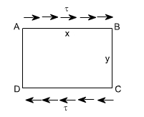
Fig. 38
It is obvious that these stresses can only be balanced by tangential forces on planes AD and BC. These are known as complementary shear stresses. i.e. the existence of shear stresses on sides AB and CD of the element implies that there must also be complementary shear stresses on to maintain equilibrium.
If the shear stress varies then at a point then t may be defined as
$$τ=\lim_{δA→0}{\frac{δP}{δA}}$$
Fig. 39
Shear strain is defined as the tangent of the angle γ, and is equal to the length of deformation at its maximum divided by the perpendicular length in the plane of force application, which sometimes makes it easier to calculate:
$$\tan{γ=\frac{δ}{L}≈γ}$$
You already be familiar with Hooke's law. Hooke's law does not only apply to normal forces. It has many applications, one of which is the shear stress/strain relationship: $τ=G∙γ$
where G – modulus of rigidity or shear modulus.

Lecture 12
Torsion
Torsion is the twisting of an object due to an applied torque. In this lecture, discussion is limited to torsion of circular bars only.
First, we take a few basic assumptions:
- Plane sections perpendicular to the axis of a circular member before application of torque remains plane even after application of torque;
- Shear strains vary linearly from the central axis reaching a maximum value at the outer surface.
- For linearly elastic material, Hooke's law is valid. Hence shear stress is proportional to shear strain.
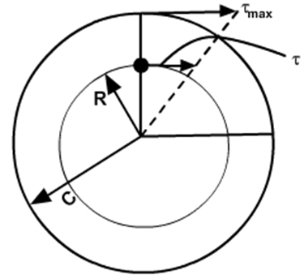
Fig. 40
Since shear stress varies linearly across the section,
$$τ=τ_{max}∙\frac{R}{C}$$
where $τ$ is the shear stress at a point of raidus R, C is the radius of the member.
Torque $T=\int_{A}{τRdA=}\int_{A}{GγRdA=\int_{A}{τ_{max}\frac{R^{2}}{C}dA}}=\frac{τ_{max}}{C}\int_{A}{R^{2}dA=\frac{τ_{max}}{C}J_{P}}$
where $J_{p}$ is the polar moment of inertia of the circular section.
$$τ_{max}=\frac{T∙C}{J_{p}}$$
Consider a circular shaft subjected to torque. It is assumed that plane sections
perpendicular to the axis remain plane even after loading. Isolating an element form such a member
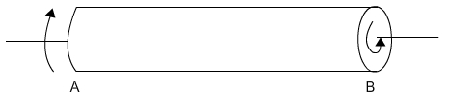

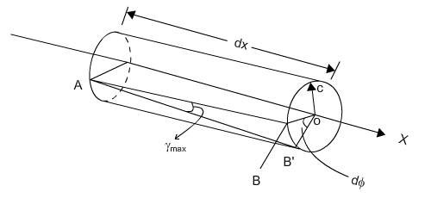
Fig. 41
A line segment in the surface of the shaft, AB is initially parallel to the axis of the shaft. Upon application of torque, it occupies a new position AB'. The segment OB now occupy the position OB' and from Fig. 40:
$$BB^{'}=C∙dφ$$
$$BB^{'}=dx∙γ$$
$$\frac{dφ}{dx}=\frac{γ}{C}$$
Since $τ=G∙γ$
$$dφ=\frac{τ}{GC}dx=\frac{T}{GJ_{p}}dx$$
This equation gives the relative angle of twist between any two sections of a shaft distance dx apart.
$$φ=\int_{L}{\frac{T}{GJ_{p}}dx=\frac{TL}{GJ_{p}}}$$

Bending
Apart from axial and torsional forces there are other types of forces to which members may be subjected. In many instances in machine design, members must resist forces applied laterally or transversely to their axes. Such members are called beams.
For the axially or torsionally loaded members previously considered, only one internal force was required at an arbitrary section to satisfy the conditions of equilibrium. However, even for a beam with all forces in the same plane, i.e., a planar beam problem, a system of three internal force components has to be developed. These are the axial force, the shear, and the bending moment.
Supports are identified by the resistance offered to forces:
Rollers – resists forces in a direction along the line of action.

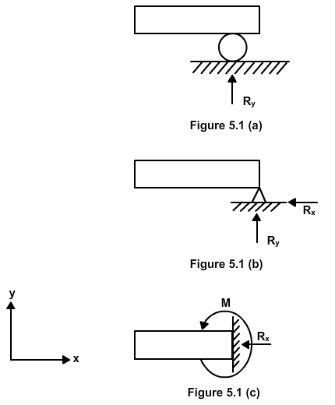
Fig. 42
Pins: resists forces in any direction of the plane.

Fig. 43
Fixed support: resists forces in any direction. Resists moments.
Fig. 44
Depending on the supports used:
1) Simply supported – pinned at one end and roller at the other
2) Cantilever – fixed at one end and the other end free
3) Fixed beam – fixed at both ends.
When all the forces are applied in a single plane, the three equations of static equilibrium are available for analysis.
$$\sum{F_{x}=0; \sum{F_{y}=0; \sum{M_{z}}=0} }$$
Employing these, the reactions at supports could be found out.
For a beam with all forces in one plane, three force components are internally developed:
• Axial force
• Shear
• Bending Moment
Procedures are to be established for finding these quantities.
Method of sections is illustrated by the following example.
Find reactions at supports for the cantilever shown in Fig. 45 subjected to uniformly distributed load.
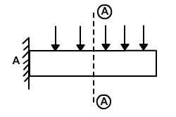
Fig. 45
Cut the cantilever along section A-A and obtain free body diagram as given in Fig. 46.
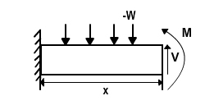
Fig. 46
The segment of the beam shown in this figure is in equilibrium under the action of external forces and internal forces and moments.
$\sum{F_{x}=0}$ gives $N=0$
$\sum{F_{y}=0 }$ gives V= -wx
$\sum{M=0}$ gives $M-\frac{wx^{2}}{2}=0 M=\frac{wx^{2}}{2}$
Plot of shear and bending moment values on separate diagrams could be obtained. Magnitude and location of different quantities can be easily visualized. Shear Force and Bending Moment Diagrams are essential for designers to make decisions on the shape and size of a beam.

Lecture 13
Definition of allowable stress
If a member is so designed that the maximum stress as calculated for the expected conditions of service is less than some certain value, the member will have a proper margin of security against damage or failure. This certain value is the allowable stress, of the kind, and for the material and condition of service in question. The allowable stress is less than the “damaging stress” because of uncertainty as to the conditions of service, nonuniformity of material, and inaccuracy of stress analysis. The margin between the allowable stress and the damaging stress may be reduced in proportion to the certainty with which the conditions of service are known, the intrinsic reliability of the material, the accuracy with which the stress produced by the loading can be calculated, and the degree to which failure is unattended by danger or loss.
The allowable stress is taken as either the yield point or ultimate strength divided by a factor of safety. The ratio of this strength (ultimate or yield strength) to allowable strength is called the factor of safety.

Basic concepts and definitions of the science of machines and mechanisms

The theory of machines and mechanisms is an applied science that is used to understand the relationships between the geometry and motions of the parts of a machine or mechanism and the forces that produce these motions. The knowledge of this subject is very essential for an engineer in designing the various parts of a machine.
There are two completely different aspects of the study of mechanical systems, design and analysis.
The concept embodied in the word “design” might be more properly itermed synthesis, the process of contriving a scheme or a method of accomplishing a given purpose. The role of science in the design process is merely to provide tools to be used by the designers.
Probably the largest collection of scientific methods at the designer's disposal fall into the category called analysis. These are the techniques that allow the designer to critically examine an already existing or proposed design in order to judge its suitability for the task.
We should always bear in mind that although most of our effort may be spent on analysis, the real goal is synthesis, the design of a machine or system. Analysis is simply a tool. It is, however, a vital tool and will inevitably be used as one step in the design process.
The initial problem in the design of a mechanical system is understanding its kinematics (from the Greek word kinema, meaning motion). Kinematics is the study of position, displacement, rotation, velocity and acceleration.
Dynamics is that branch of theory of machines which deals with the forces and their effects, while acting upon the machine parts in motion.
Machines are devices used to alter,transmit and direct forces to accomplish a specific objective. Machines perform mechanical movements to convert energy, materials, information and perform positive work at the same time.
Instrumentation are technical devices that perform functions of measurement, control, counting, accounting, calculation, recording, blocking, protection, adjustment, regulation, monitoring, etc. Instrumentation do not commit of positive work.
Mechanisms are an integral part of machines and instrumentation. A mechanism can be considered rigid parts that are arranged and connected so that they produce the desired motion of the machine. Synthesis is the process of developing a mechanism to satisfy a set of performance requirements for the machine. Analysis ensures that the mechanism will exhibit motion that will accomplish the set of requirements.
We shall use the word link to designate a component of a mechanism. A link is assumed to be completely rigid.
The links of a mechanism must be connected together in some manner in order to transmit motion from the driver, or input link, to the follower, or output link. These connections, joints between the links, are called kinematic pairs (or just pairs), because each joint consists of a pair of mating surfaces, or two elements, with one mating surface or element being a part of each of the joined links. Thus we can also define a link as the rigid connection between two or more elements of different kinematic pairs.
When several links are movably connected together by kinematic pairs, they are said to form a kinematic chain. If every link in the chain is connected to at least two other links, the chain forms one or more closed loops and is called a closed kinematic chain; if not, the chain is referred to as open.
Recalling a definition of a mechanism, we see that it is necessary to have a closed kinematic chain with one link fixed. When we say that one link is fixed, we mean that it is chosen as a frame of reference for all other links – that is, that the motions of all other points on the linkage will be measured with respect to this link. This link in a practical machine usually takes the form of a stationary platform or base is called the frame or base link. When the frame link is specified, the closed kinematic chain is called a mechanism.
There are two types of mechanisms: planar and spatial. In planar mechanisms, all particles describe plane parallel curves in space while in spatial mechanisms there is no restrictions on the relative motions of particles.
Lecture 14
Classification of kinematic pairs
Kinematic pairs are divided into higher pairs and lower pairs. The lower pairs have surface contact between the pair elements, while higher pairs have line or point contact between the elemental surfaces.
A pair is said to be self closed if the links in the pair have direct mechanical contact, even without the application of external force. A kinematic pair is said to be force closed if the links in the pair are kept in contact by the application of external forces
A more useful means to classify pairs is by the number of degrees of freedom that they allow between the two elements joined. Kinematic pairs are divided into five classes according to the number of conditions of linkage S imposed by the linkage. The number of degrees of freedom of a kinematic pair W = 6 — S.
Each of the conditions of linkage removes one degree of freedom—that is, the possibility of one of the six independent relative motions in space. Three translational motions (in the direction of the three coordinate axes) and three rotational motions (around the axes) are possible in the rectangular system of coordinates.
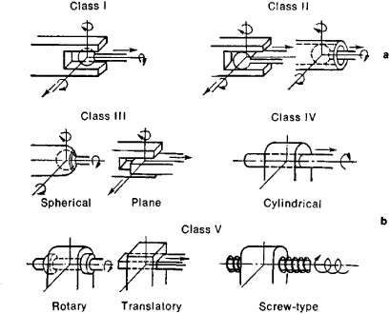
Fig. 47

Kinematic Diagrams
In analyzing the motion of a machine or mechanism, it is often difficult to visualize the movement of the components in a full assembly drawing. So we need to use kinematic diagrams (kinematic scheme) to illustrate the connectivity of links and joints of a mechanism or machine instead of full assembly drawing.
Real links can be of any shape, but a “kinematic” link is defined as a line between joints that allow relative motion between adjacent links. Joints can allow rotation, translation, or both between the links joined. The possible joint motions must be clear and obvious from the kinematic diagram.
A kinematic diagram should be drawn to a scale proportional to the actual mechanism. For convenient note, the links are numbered, starting with the frame as link number “1” and the joints need to be lettered with alphabet.
Examples of important mechanisms.
Fig. 48
The sketch of linkage arranged as shown in Fig. 48 is known as the slider-crank mechanism. Link 1 is a stationary base or a frame, link 2 is the crank, link 3 is the connecting rod, and link 4 is the slider.
Fig. 49
The 4-bar linkage consists of 4 pin-connected rigid links as shown in Fig. 49. Link 1 is the frame, which is stationary, link 2 is the crank, which makes complete revolutions, link 3 is the coupler, and link 4 is the rocker, which performs the desired task.
The slotted link mechanism (The Scotch Yoke mechanism) is sketched in Fig. 50. It consists of the frame 1, the crank 2, the slide block 3, the slotted link 4.
Fig. 50
This simple mechanisms is important, as it is the base of many other mechanisms.

Lecture 15
Mobility of mechanisms
The mobility of a mechanism is its number of degrees of freedom. This translates into a number of independent input motions leading to a single follower motion. It is possible to determine number of DOF of a mechanism directly from number of links and number and types of joints. Professor Chebishev did it in 1861 and Grubler supplemented in 1887.
A single unconstrained link AB (Fig. 51) has three DOF in planar motion: two translational and one rotational. Thus, two disconnected links AB and CD will have six DOF.
Fig. 51

Fig. 52
When link CD is connected to link AB by a revolute pair at A, the position of link CD relative to another is now determined by a single variable and thus has one DOF. Thus, the two links connected by a revolute joint have four DOF. One can say that by connecting the two previously disconnected links by a revolute joint, two DOF are eliminated. Similar considerations are valid for a prismatic joint.
Since the revolute and prismatic joints make up all low-pair joints in planar mechanisms, the above results can be expressed as a rule: a low-pair joint reduces the mobility of a mechanism by two DOF.
Consider a plane mechanism with m number of links. Since in a mechanism, one of the links is to be fixed, therefore number of movable links n= (m – 1). Total number of DOF = 3n before they are connected to any other link. A mechanism with n number of movable links connected by $p_{5}$ number of V class joints or lower pairs (single DOF pairs) and $p_{4}$number of IV class higher pairs (two DOF pairs), then number of DOF of a mechanism is given by
$$W=3∙n-2∙p_{5}-p_{4}$$
In Fig. 53 the mobility of various configurations of connected links is calculated. All joints are low-pair ones. Note that the mobility of the links in a) is zero, which means that this system of links is not a mechanism, but a structure. At the same time, the system of interconnected links in d) has mobility 2, which means that any two links can be used as input links (drivers) in this mechanism. A slider-crank b) and four-bar c) mechanisms have mobility W=1.
Fig. 53
The approach used to determine the mobility of a planar mechanism can be easily extended to three dimensions. Each unconnected link in three-space has 6 DOF, and any one of the lower pairs can be used to connect them, as can higher pairs with more freedom. A one-freedom joint removes 5 DOF, a two-freedom joint removes 4 DOF, etc. This leads to the Somov-Malishev mobility equation for spatial linkages:
$$W=6∙n-5∙p_{5}-4∙p_{4}-3∙p_{3}-2∙p_{2}-1∙p_{1}$$
where the subscript refers to the number of conditions of the joint. We will limit our study to 2-D mechanisms in this course.

